Ideation Phase
AI FitTrack – Brainstorm & Idea Prioritization
Date | 24 September 2026
Team ID | AI-FITTRACK-TEAM
Project Name | AI FitTrack – AI-Powered Fitness Tracking System
Maximum Marks | 4 Marks
Brainstorm & Idea Prioritization Template:
Brainstorming for AI FitTrack provides a structured space to generate ideas for tracking, analytics, AI coaching and user engagement before selecting implementation priorities.
Use this template to generate a broad set of ideas, group them by theme, then prioritize them against user value and implementation effort.
Step-1: Team Gathering, Collaboration and Select the Problem Statement

Step-2: Brainstorm, Idea Listing and Grouping

Step-3: Idea Prioritization

Step-1: Problem & Opportunity
• Core problem: fragmented workout tracking.
• Opportunity: unify records, progress analytics and personalized coaching.
• Constraint: protect personal data and keep external AI dependencies isolated.
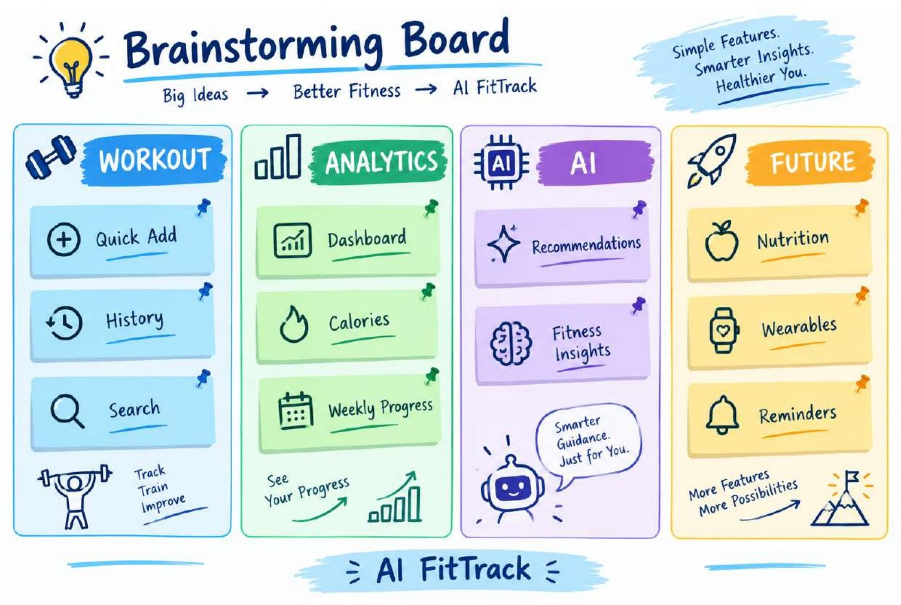
Step-2: Idea Generation & Grouping
Idea Group | Idea | User Value | Effort
Workout Tracking | Quick add workout | High | Low
Analytics | Weekly progress dashboard | High | Medium
AI Coaching | Goal/experience-based recommendation | High | Medium
AI Coaching | Fitness insight summary | High | Medium
Engagement | Workout reminders | Medium | Medium
Nutrition | Meal and nutrition tracking | Medium | High
Integrations | Wearable device sync | Medium | High
Analytics | BMI and trend analysis | Medium | Medium
Step-3: Idea Prioritization
Prioritization should consider user value, implementation effort, security impact, dependency risk and alignment with the core fitness tracking workflow.
Priority | Idea | Value | Effort | Decision
P1 | Authentication + workout CRUD | High | Medium | Core
P2 | Dashboard analytics | High | Medium | Core
P3 | Gemini recommendation/insights | High | Medium | Core / provider dependent
P4 | Search + filters | High | Low | Core
P5 | Nutrition / wearable integrations | Medium | High | Future
